Introduction
Windows of Opportunity is a web development company that specialize in designing and creating the best websites in the world. The company was founded by William Fence on April 1st, 1995. The headquarters is located in Redmond, WA, United States of America. Its main offices are located in Los Angeles, California, United States. It currently employs 15 workers including one manager, one assistant manager, a secretary, a receptionist, office accountants, 5 office workers and 5 web developers.

Company Requirements
Windows of Opportunity has asked for an upgraded network for their main office in Los Angeles. They’ve been using their third network, which was put in in 2001 and hasn’t been updated since. Windows of Opportunity would like a new network for improved work quality among staff and managers, as well as the opportunity for more profits to be made within the web development sector. Improved efficiency, which will help sharing files among workers and communication between colleagues, is another reason Windows of Opportunity wants a new network put into their offices. They require two separate towers with different hardware, one focusing on web developers and the other focusing on the office workers. Each require the same software, but both groups won't necessarily need to use the software. The company has requested that all computers come with Windows 8 operating system, web developers computers come with a hard drive bigger than 500GB, while office workers should have a hard drive in and around 500GB.
Aims
The aims of this project are;
- To build a functional network
- Client server

Hardware/Software for Users
The web developers in the company will use the XPS 8700 Desktop. This desktop comes with a 4th generation Intel Core i7-4790 processor with an 8M Cache. It initially comes with 12GB of RAM and a 1TB hard drive. There's an optional Dell 22' Monitor, which the company is adding, and a 12 month subscription to McAfee Live Safe XPS. The video card included in this desktop is a NVIDIA GeForce GTX 745 4GB DDR3, and there's an integrated sound card. Keyboard and mouse are included with the desktop as well as hardware support for up to one year.
The office users will have a different desktop with different hardware, as they don't necessarily need the same hardware that the web developers may need. The office users will use the Inspiron Small Desktop, which comes with the Intel Celeron Dual Core J1800 processor with a 500GB hard drive. These desktops will have 4GB of RAM, and come packaged with the Dell E-series E2014H LED monitor. As with the XPS 8700 desktop, the Inspiron Small Desktop also comes with a 12 month subscription to McAfee Live Safe. This desktop comes with an Intel HD graphics video card, and a keyboard and mouse. Like the previous desktop, this one also has a hardware support for up to one year.
Both desktops will have the same software. The operating system that will be used is Windows 8.1, as this is what the two desktops come with pre-installed. The option to switch to Linux is there, but as most of the users are familiar with Windows, this was the best option. Both desktops will have Microsoft Office, this will be mainly used by office users as it comes with Word, Excel, One Note, Power Point, Outlook, Access and Publisher. The internet browser that will be pre-installed on the machines will be Internet Explorer, which will be used mainly for the web developers. Google Chrome and Mozilla Firefox will also be used. Both desktops will also have AdobeReader XI and McAfee Antivirus protection.
Network Hardware/Software
In the two server rooms (main and backup), there will be the PowerEdge T320 Tower Server. This will help boost office efficiency, with matching enterprise-class features with a dense memory footprint that enables the company to easily address core business applications quickly and efficiently. The server has up to 16 hot-swap drives as well as hardware and software RAID options to help maximize data management and it's protection. There is 192GB memory (6 DIMM slots), 32TB internal storage, 2.5MB cache per core, core options include: 2, 4, 6, 8, 10. The processor for the server is an Intel Xeon processor and Intel Pentium processor. The operating system(s) that comes with the server include; Microsoft Windows Sever 2012, Microsoft Windows Server 2012 Essentials, Microsoft Windows Server 2008 R2 SP1, Novell SUSE Linux Enterprise Server, Red Hat Enterprise Linux, with virtualisation options including; Citrix XenServer, Wmware vSpehere ESXi and Red Hat Enterprise Virtualisation. The PowerEdge T320 Tower Server will be placed in a 12u CSS Server Cabinet.
The network switch that the company will be using is the Dell Networking Z-Series Core and Aggregation Switches. It's advertised as Dells most powerful switch to date, that offers superior density and a performance of over 10Tbps. The key features include; 132 ports of 40GbE, the company will be able to licence 36, 84 or 132 ports according to their needs, which will be helpful for expansion and low latency. The Z-Series also has four times higher throughput and 25% lower latency, and user configurable table adjustments to allow for expanding and virtualised data centre characteristics. Another switch option for the company that is recommended is the HP 1920 Switch Series, as it has 48 10/100/1000 ports, maximum and 4 SFP 1000 Mbps ports, and throughput 77.4 Mpps. Cisco ASR 1013 will be the router that the company is using, and everything will be connected with CAT 7 cables. While a more expensive option than using CAT 5 cables, CAT 7 cables are considered the most durable and have a longer life span than CAT 5 and CAT 6, improving it's overall return on investment, and is the best choice for wiring whilst keeping future expansion in mind.

Floor Plan and Logical Layout
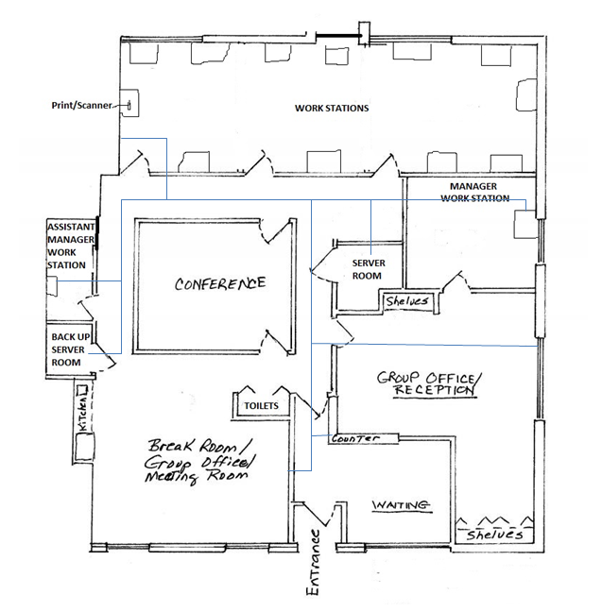
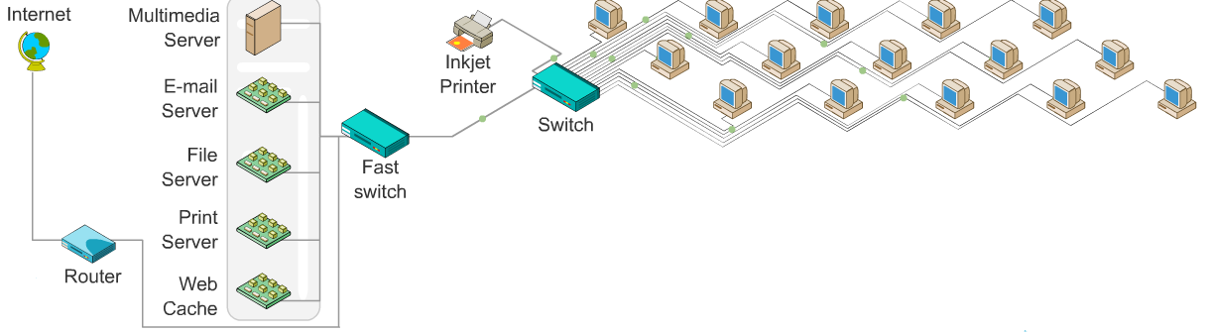
Configuration/Analysis
Steps to set it up (Explain)
Conclusion and Recommendations

